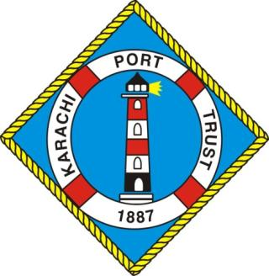

KPT YEAR BOOK
2023-24

Introduction
Karachi Port is the nation’s most important economic asset bearing a proud and distinguished history. A constant and on-going development programme based on scientific maritime principles has equipped the port to ably meet both the present and future requirements of cargo-handling. This impressive pinnacle of achievement has been reached after more than a century of development work and far-sighted planning.

History of the Port
By 1852, Karachi was an established city with a population of 14,000 and a prosperous overseas trade. The modern port began to take shape in 1854, when the main navigation channel was dredged and a mole or causeway was constructed to link the main harbour with the rest of the city.

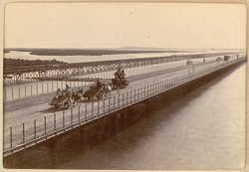
The photograph taken in 1900, with a general view along the iron Napier Mole Bridge connecting Karachi with Keamari, the landing place for all goods and passengers bound for the city. Karachi, now the capital of the Sindh province in the lower Indus valley, was once the capital of Pakistan and continues to be the country's commercial hub and largest city. Its history prior to the 19th century is largely unrecorded but it is believed to be the ancient port of Krokala on the Arabian Sea, visited by Alexander's admirals in 326 BC. Karachi is built around a bay which is a natural harbour and protected from storms by a group of small islands. The small fishing village of Karachi became a trading post when the Talpur Mirs of Sindh built a mud fort here in the 18th century, but the port remained small. It was completely transformed when its harbour was developed by the British after they conquered Sindh in the mid-19th century. The main navigable channel was dredged and the construction of a mole or causeway joining the main harbour with the rest of the city was undertaken. The Napier Mole Bridge was constructed about five years later, together with the Manora Breakwater, Keamari Groyne, Native Jetty and Chinna Creek.
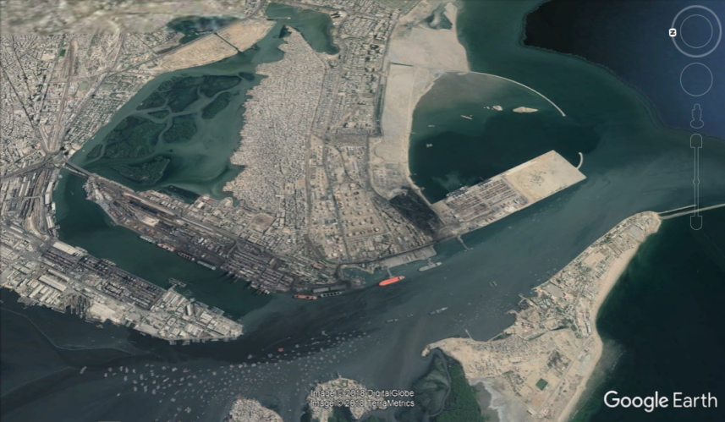
Location
In the northern coast of the Arabian Sea, from the straits of Hormuz in the west and past the Indus River in the east, lies about 600 kilometres of Pakistan’s serene coastline. Ideally located with well developed connections with Afghanistan, Central Asia and Western China; Karachi Port serves as gateway to the region.

Our Vision
“To Transform Karachi Port into a Modern, Competitive, User Friendly Port and a Transhipment Hub of the Region with Hinterland Connectivity”

Governance Structure
Karachi Port is governed by the Ministry of Maritime Affairs. Chairman is the Chief Executive and also Chairman of KPT Board of Trustees. He is assisted by eight General Managers, responsible for the Operations, Finance, Planning and Development, Engineering, Administration, Civil Works, Real Estate Development and Legal Division(s). All policy decisions are vested in KPT Board of Trustees.
KPT Board of Trustees
The Board comprises eleven Trustees including Chairman. Chairman and five Trustees including one associated with Labour Unions are appointed by the Federal Government. Five Trustees are notified by Federal Government after they are elected / nominated by the respective bodies, i.e.
- Federation of Pakistan Chamber of Commerce & Industries
- Karachi Chamber of Commerce & Industry
- Karachi Cotton Association
- Pakistan Ship Agent’s Association
- Karachi Municipal Corsporation

FACILITIES AT KARACHI PORT
Port Operations
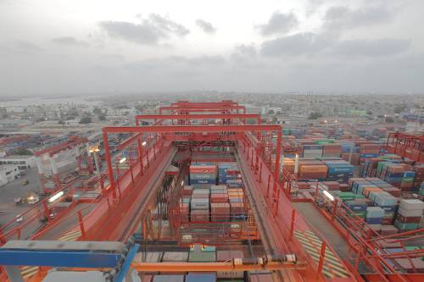
The containerized cargo started coming to Karachi Port from 1973. The American President Line has for the first time given service within a fortnight to bring 100 containers from US which was inaugurated by the then Prime Minister. Since then cargo freight has mostly shifted to containerized form and is growing every year.

KPT is poised to become the regional shipment hub, and its 3 world-class terminals serves major shipping lines connecting to ports all over the world. Spread out over almost 33 square kilo meters, KPT is a state of the art port with easy access for ships calling Karachi Port.

The Port itself consists of three wharves. The East Wharf has 17 multipurpose berths (Berth No. 1 to 17), the West Wharf has 13 berths (Berth No. 18 to 30) and the South Wharf has 4 berths
(Berth No. 31 to 34). Each of the wharves has a dedicated container terminal with a designed depth of 13-16 meters. The Karachi Port Trust has three oil piers to handle liquid cargo.

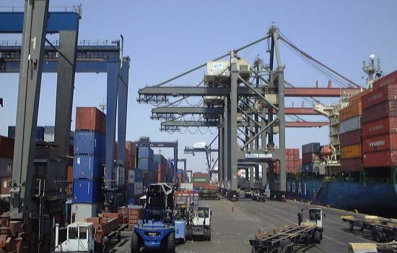
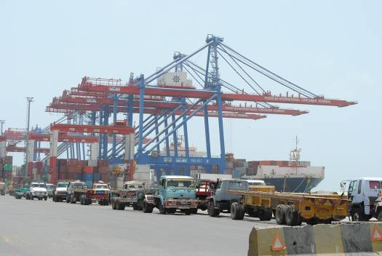
Container Facilities
Karachi International Container Terminal (KICT), Karachi Gateway Terminal Limited (KGTL) and South Asia Pakistan Terminals Limited (SAPTL) are the three dedicated Container Terminals located on the port developed in collaboration with private partnership and equipped with the latest cargo handling equipment.

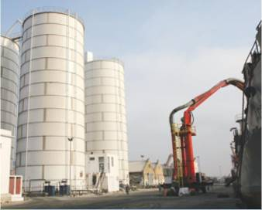
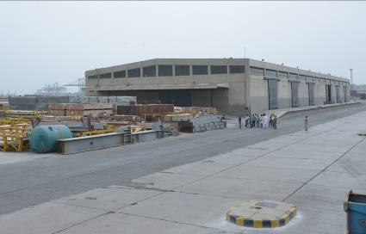
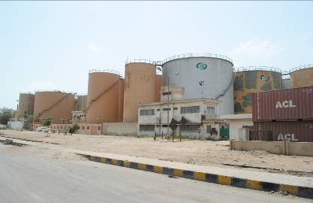
Warehousing Facilities
KPT provides facilities at each berth for transit, storage, warehousing and clearance of cargo and containers. Additional services are provided to port customers with respect to dangerous cargo handling at packing stations for immediate uploading and packaging of dry goods, custom storage yards, oil tank-ages, bulk cargo stacking areas and container freight stations.

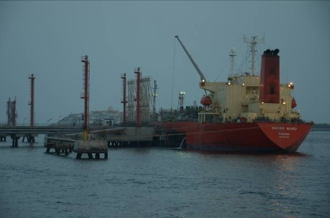
Liquid Cargo Terminal
KPT has three dedicated liquid cargo piers used for handling POL and non-POL products. These terminals are equipped with the most modern loading and unloading facilities backed by equally sound safety measures.

Ship Maintenance & Repair
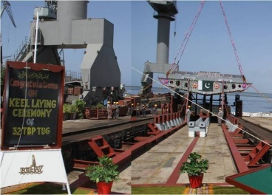
KPT has its own dry dock facility at Manora that enables quick boat repair and maintenance. For more extensive work, be it for larger ships; a shipyard run by Karachi Shipyard and Engineering Works is also located near the Port.

Port Safety & Security
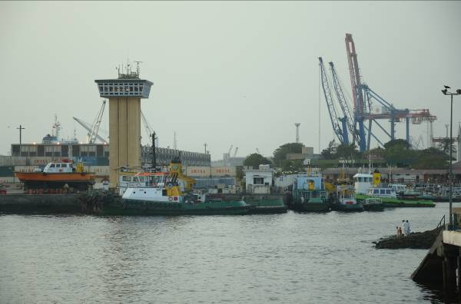
KPT is committed to the utmost safety and security of goods and personnel. A sophisticated system of radars, buoys, and technology system have been employed to monitor incoming vessels and, thereafter, to guide them to their berthing space. Additionally, the dedicated Port Security Force, Port Technology Units, Marine Pollution Control Department and Fire Fighting Unit at Karachi Port Trust works round the clock to provide security to Karachi Port that includes cargo and port users.

Dredging & Reclamation Work
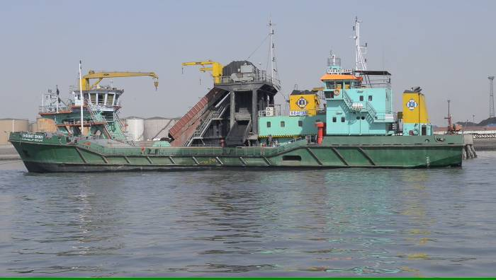
Dredging is a constant activity of a port and is conducted to maintain required depth at all times within the port channel to facilitate shipping lines and vessels calling Karachi Port. Due to high and low tides, the flow of tidal current brings siltation inside the channel which gradually reduces the depth inside the port channel. KPT has a flotilla of dredgers and is the sole port of Pakistan to have this facility. The Port has over the years remained in constant pursuit to acquire latest dredgers to meet its requirements.

ACHIEVEMENTS

Karachi Port Receives $50 Million Upfront Payment from AD Ports Group
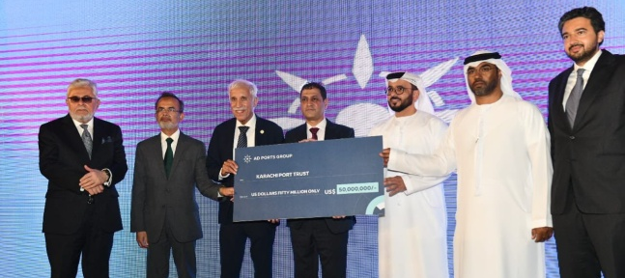
KPT has received a substantial upfront payment of $50 million from Abu Dhabi Ports Group (AD Ports) on 22-04-2024. This payment is part of a new concession agreement between the two parties.
Minister of Maritime Affairs Mr. Qaiser Ahmed Sheikh, the then Federal Secretary Minister of Maritime Affairs Mr. Iram Anjum Khan, Chairman KPT Syedain Raza Zaidi and other notables have attended the august ceremony.
In his remarks during the event, Minister for Maritime Affairs, Mr. Qaiser Ahmed Sheikh, emphasized the government's unwavering commitment to the maritime sector and underscored the pivotal role of partnerships in fostering sustainable growth and development. He expressed confidence that the collaborative efforts between the two countries would yield mutual be nefits, strengthening bilateral ties and contributing to the advancement of both nations.
During the signing ceremony, Chairman KPT, Syedain Raza Zaidi, expressed his gratitude and excitement for the partnership with AD Ports Group. He highlighted the transformative opportunities that this investment brings to Karachi Port, emphasizing the significance of the $50 million contribution and the strategic alliance between KPT and AD Ports Group.
This significant investment is expected to enhance Karachi Port's efficiency and capacity, enabling it to handle larger vessels and increased cargo volumes. The funds will be utilized for infrastructure upgrades and expansion projects, further strengthening Karachi Port's position as a key maritime hub.
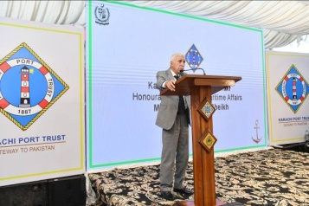
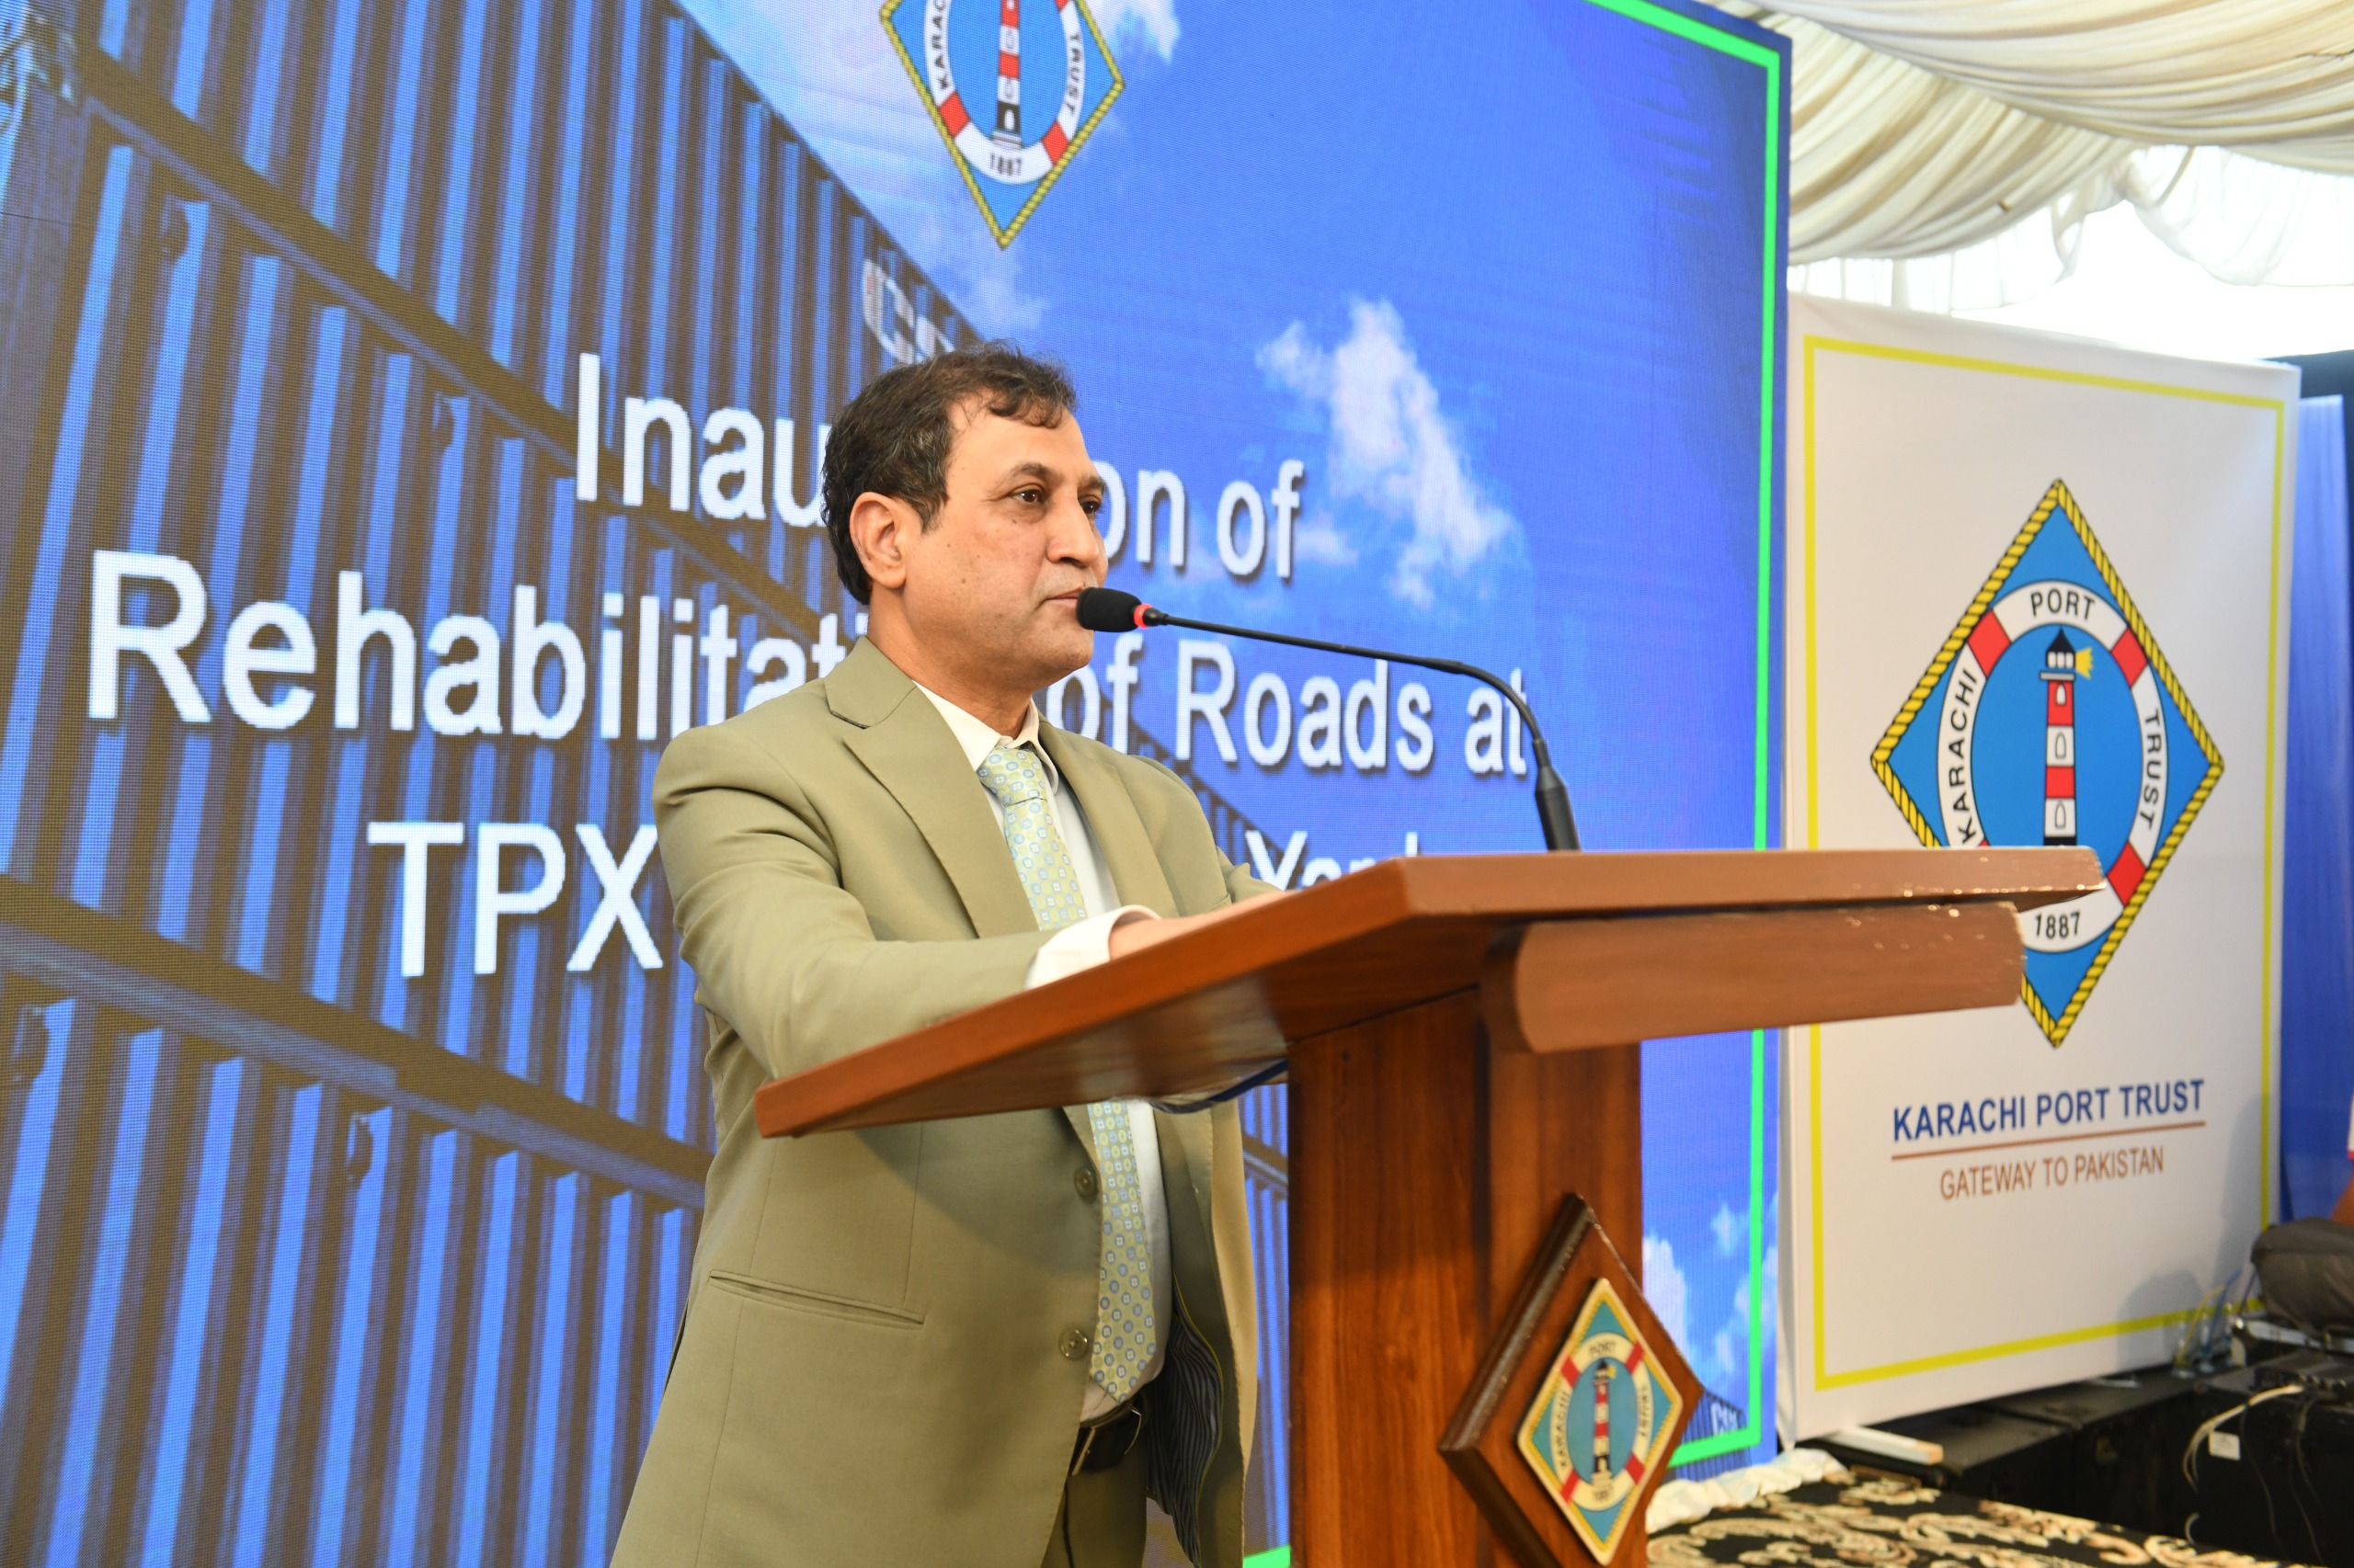Minister for Maritime Affairs inaugurated the reconstructed road inside TPX
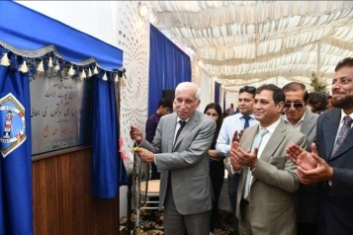
Minister of Maritime Affairs Mr. Qaiser Ahmed Sheikh inaugurated the reconstructed road inside the Thole Produce Yard (TPX) on 9th May 2024. He was accompanied by Chairman KPT Syedain Raza Zaidi during the occasion which was well attended by all the General Managers of KPT as well by dignitaries.
It is a significant achievement that has enhanced operational efficiency of the region's busiest container yard making it more safe and secure. Spanning 139 acres, TPX Container Yard receives approximately 600 containers daily, contributing significantly to national revenue. The rehabilitation initiative, covering a 5-kilometer stretch, has mitigated damages and safety concerns caused by torrential rains that became source of operational disruption earlier.
While speaking during the occasion the Federal Minister for Maritime Affairs, Mr. Qaiser Ahmed Sheikh stressed on collective responsibility for Pakistan's economic independence, expressing gratitude to all departments involved in the project.
Chairman Syedain Raza Zaidi commended the dedication and perseverance exhibited by the teams involved in the rehabilitation efforts, emphasizing the significant impact of the renovated roads in ensuring smoother operations within TPX Container Yard.

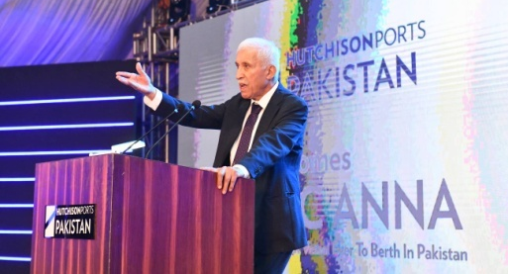
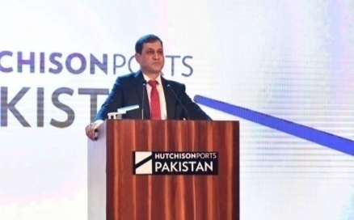
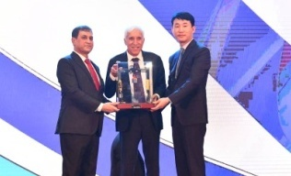
MSC ANNA, the Largest Container Vessel, Arrives at Karachi Port Trust
KPT proudly welcomed the historic arrival of MSC ANNA, the largest container vessel ever to docked in Pakistan on 31st May 2024, at its South Asia Pakistan Terminal Limited (SAPTL). This milestone reaffirms KPT's position as a premier Maritime Hub in the region.
With dimensions of 400 meters in length and a capacity of 19,368 TEUs, MSC ANNA exemplifies KPT's progress and strategic significance. Governor Sindh Mr. Kamran Khan Tessori commended the successful handling of the massive vessel, noting its positive impact on the country's economy.
Federal Minister for Maritime Affairs, Mr. Qaiser Ahmed Sheikh, highlighted the fruitful partnership between KPT and Hutchison Ports Pakistan, emphasizing opportunities for growth in the blue economy. Chairman KPT, Syedain Raza Zaidi, underscored Karachi Port's pivotal role in regional trade.
CS Kim, CEO Hutchison Ports Pakistan said that Hutchison Ports Pakistan is proud to host such massive ships, reflecting our commitment to enhance Pakistan's maritime industry. Our facility regularly handles large vessels, previously berthing ships with capacities up to 14,000 TEUs and lengths of 366 meters. Now, with the arrival of the CV MSC ANNA, which has a length of 400 meters and a capacity of 19,368 TEUs, we continue to demonstrate our capacity to handle the largest vessels efficiently.
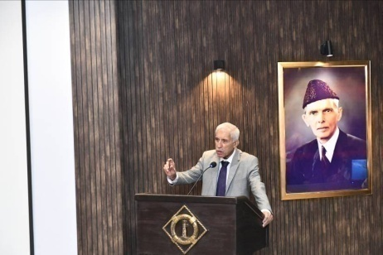
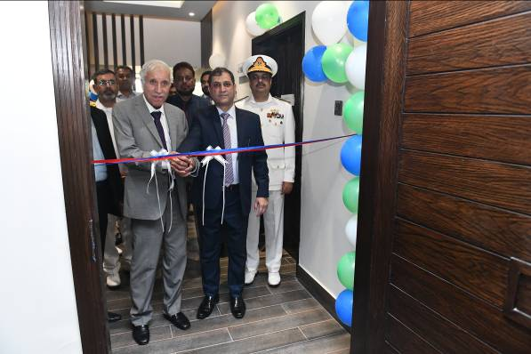
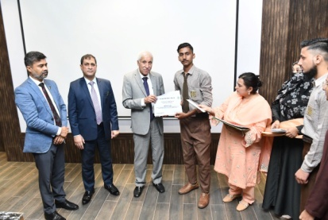
Renovation of KPT Staff College Inaugurated by Federal Minister for Maritime Affairs
Federal Minister for Maritime Affairs, Mr. Qaiser Ahmed Sheikh, accompanied with Chairman KPT Syedain Raza Zaidi, inaugurated the renovated KPT Staff College on 28th May 2024. The college underwent its first proper renovations since establishment in 1979. Additionally, the Minister Mr. Qaiser Ahmed Sheikh recognized the outstanding performance in SSC exams and distributed cash awards and certificates of appreciation to students and teachers of KPT Schools.
Minister Mr. Qaiser Ahmed Sheikh commended KPT's dedication to train officers according to guidelines given by international standards as a proactive approach. He highlighted KPT's role as Pakistan's gateway and expressed confidence in achieving maximum benefits through collaborative efforts.
Chairman KPT Syedain Raza Zaidi expressed satisfaction over renovation works of KPT Staff College and on KPT schools' performance. He praised the efforts of concerned General Managers and their teams.
In recognition of academic excellence, Mr. Qaiser Ahmed Sheikh distributed cash prizes and certificates among students achieving top grades and their teachers. This gesture reflects KPT’s commitment to fostering academic excellence.
The inaugural ceremony signifies KPT's mission to uphold educational standards and to the advancement of maritime expertise in Pakistan. The renovated Staff College stands as a testament to KPT's dedication to excellence and its pivotal role in shaping the maritime sector's future.
Successful Refit of FB Arfa Karim and DT Mazdoor inaugurated
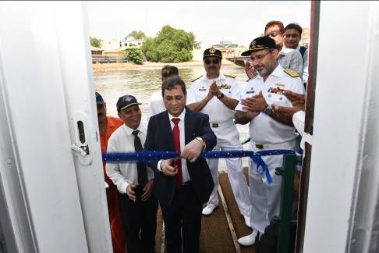
Chairman KPT Syedain Raza Zaidi inaugurated FB Arfa Karim and DT Mazdoor after their successful refit operations during a ceremony held on 2nd May 2024. He was accompanied by KPT’s General Managers.
While speaking during the occasion, the Chief Guest Chairman KPT Syedain Raza Zaidi termed these major refit of two vital vessels an achievement of a significant milestone by the Engineering Division of KPT and commended the dedication and expertise shown by Rear Admiral Habib ur Rehman HI(M) and his efficient team in bringing these vessels back to operational status. Their relentless efforts have not only restored functionality but have also enhanced the efficiency and reliability of these vessels, contributing significantly to KPT's operational capabilities. It underscores the organization's continuous efforts towards excellence and innovation in maritime infrastructure and services, he added.
The KPT Newsletter team extends heartfelt congratulations to the entire working team involved and best wishes for continued success in their future endeavors.
Strategic Partnership: Karachi Port Trust & Abu Dhabi Ports Group

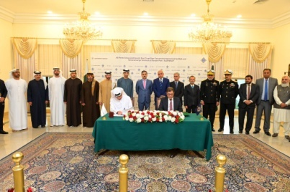
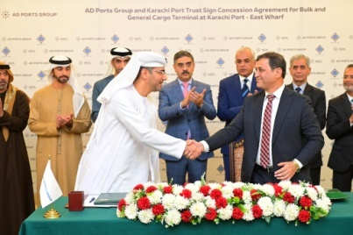
Karachi Port Trust (KPT) has signed a significant commercial agreement with Abu Dhabi Ports Group on February 4, 2024. The partnership aims to efficiently manage Bulk and General Cargo Terminals at seven berths within the East Wharf Karachi Port, strengthening maritime and logistic ties between Pakistan and the UAE. The signing ceremony was attended by the then Caretaker Prime Minister Anwaar-ul-Haq Kakar, Caretaker Minister for Communication, Railways, and former Minister for Maritime Affairs Mr. Shahid Ashraf Tarar, alongside other officials from Pakistan and distinguished figures from the UAE, including the minister of state for foreign trade Dr. Thani Bin Ahmed Al-Zeyoudi, Hamad Obaid Ibrahim Salem Al-Zaabi, UAE Ambassador to Pakistan, and other esteemed dignitaries. This agreement underscores the commitment to mutual growth and cooperation between the two nations.
In a preceding meeting with the UAE Minister of Foreign Trade, Caretaker Prime Minister Kakar conveyed his best wishes to the President of the United Arab Emirates, Sheikh Mohammed bin Zayed Al Nahyan, reaffirming the enduring brotherly relations between the two nations and solidifying the groundwork for sustained cooperation and diplomatic relations.
First-ever Advanced Computerized Hajj Balloting -2024 held at KPT
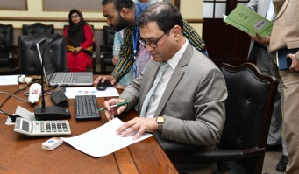
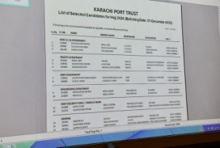
KPT continues its tradition by sponsoring the Hajj expenses for 20 aspirants, including 2 officers and 18 employees, who will perform Hajj in 2024.
A significant milestone in to religious assistance in line with the approved demand, KPT has successfully conducted its first-ever computerized balloting for the selection of employees and officers eligible for the Hajj-2024 sponsorship.
Mr. Syedain Raza Zaidi, Chairman KPT, opened the momentous occasion by initiating the computerized balloting application, a new era in the fair and transparent selection process on 7th December 2023.
Governor Sindh Unveils Vital Road Link at Keamari Boat Basin
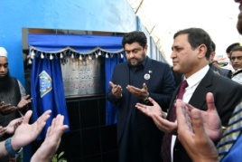
On February 15, 2024, KPT organized an event to unveil the newly rehabilitated road connecting the Keamari Boat Basin to Oil Pier-I. The ceremony was attended by Sindh Governor Muhammad Kamran Khan Tessori, who emphasized the importance of collective efforts in achieving success. Guests included Chairman of Pakistan National Shipping Corporation (PNSC), Rear Admiral Jawad Ahmed SI (M), and Mr. Farhan Essa from Essa Laboratories, along with senior management representatives from KPT.

Muhammad Kamran KhanTessori,Governor Sindh eloquently emphasized the significance of individual initiative and collective efforts in achieving success. Applauding the proactive approach of Chairman KPT and his dedicated team, the Governor signified the KPT’s crucial role in the rehabilitation project.
KPT’s oldest Terminal KICT celebrated Silver Jubilee
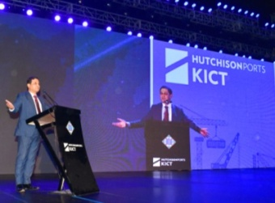
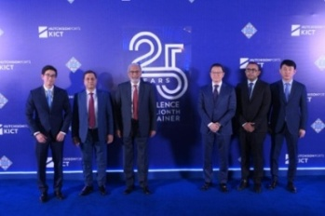
KPT's oldest terminal "Karachi International Container Terminal" celebrated a milestone, having handled 15 million TEU containers, marking the Silver Jubilee celebrations on 17th January 2024 at Karachi Port. It was attended by Chairman KPT Syed Syedain Raza Zaidi besides the senior management of KPT and other eminent personalities of the maritime sector of Pakistan.
While speaking on the occasion the Chief Guest, the then Chief Minister of Sindh, Justice (R) Maqbool Baqar highlighted on the significance of confronting global challenges and complimented KPT and KICT both for playing a key role in the buildup of national economy. He showed resolve to leave no stone unturned to facilitate Karachi Port in pursuing its development goal and advancements.
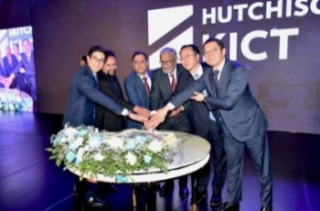
Earlier, in his key note address, the Chairman KPT Syedain Raza Zaidi congratulated KICT on their contribution towards national economy and in this connection he underlined the significance of sea ports which serves as lifelines of economies when compared the challenges faced by landlocked countries. As the oldest seaport of the country, Karachi Port is switching to the concept of landlord port and our container terminals are making commendable efforts to strengthen the national economy, added the Chairman KPT.
Hutchison Ports Managing Director Middle East and Africa Mr. Andy Tsoy also spoke during the occasion and applauded the efforts shown by KICT team in realising Corporate goals. He said that there is tremendous potential in Pakistan and that together we can progress to achieve many milestones.
The Chief Executive Officer KICT Mr. Alvin Chow has termed the unwavering commitment shown by his team is a thing that kept them on track over the years to achieve the milestone of handling 15 million containers at KICT Terminal. The proceedings concluded with mementoes presented to the then Chief Minister Sindh Justice (R) Maqbool Baqar by Chairman KPT Syedain Raza Zaidi and CEO KICT Mr Alvin Chow.

23.42 % Increase in Cargo Handling at Karachi Port at the End of F.Y 2023-24
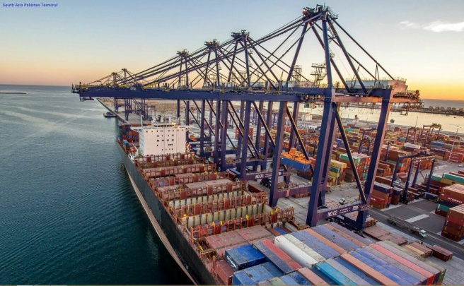
Cargo handling operations, including Import and Export at Karachi Port Trust remained outstanding at the end of fiscal year 2023-24 and witnessed a notable rise of 23.42% in cargo handling. The entire freight closed at 51.65 million tons in which the Dry Cargo 40.24 million tons with 31.39% growth and Liquid Bulk Cargo 11.41 million tons with 1.68% increased, as well as in the last year the same was 41.85 million tons in which the Dry Cargo 30.63 million tons and Liquid Bulk Cargo 11.22 million tons was handled in fiscal year 2022-23.
The breakup shows that overall Export Cargo handling at KPT closed at 18.80 million tons with the stunning 47.15% rise at the end of fiscal year 2023-24, whereas the same was 12.78 million tons during the fiscal year 2022-23. Similarly, the total Import cargo handling at KPT is noted as 32.85 million tons showing 13% jump from 29.07 million tons of the fiscal year 2022-23.
The further breakdown shows that the Export Dry Cargo handled at KPT at the end of fiscal year 2023-24 is closed at 17.66 million tons with 49.12% increase due to extraordinary Clinker handling, while the same was 11.84 million tons during the fiscal year 2022-23. Similarly, the Export Liquid Bulk Cargo of KPT noted at 1.14 million tons with 22.16% increase due to contribution of Furnace Oil and Molasses etc., however the same was 0.93 million tons during the fiscal year 2022-23.
In continuation of above, the Import Dry Cargo handled at KPT recorded at 22.58 million tons with 20.21% increase mostly due to Wheat, Fertilizer, R/Phosphate and Iron Ore etc., whereas the same was 18.78 million tons during the fiscal year 2022-23. Similarly, the Import Liquid Bulk Cargo handled at KPT is 10.27 million tons, whereas the same was 10.29 million tons during the fiscal year 2022-23.
Karachi Port Trust’s sturdy performance in container handling highlights its vital role in international trade and economic development. With 57% of its total cargo being containerized, KPT’s operational success in container handling is 2.28 million TEUs at the end of fiscal year 2023-24, showing 17.90% increase from 1.93 million TEUs of the fiscal year 2022-23.
Karachi Port showed significant performance in ship movement by handling 1767 ships at the end of fiscal year 2023-24 and witnessed the growth of 5.68% as compared to 1672 ships handled in the fiscal year 2022-23.
Karachi Port contemporary performance by handling 79.7 million Gross Registered Tonnage (GRT) at the end of fiscal year 2023-24 with the considerable rise of 16.69% increase from 68.3 million handled in the fiscal year 2022-23.
KPT provides On-Dock cross-stuffing of in-transit containers at designated areas on both East and West Wharves to enhance global logistics and trade. Through strategic planning and stakeholder engagement, KPT aims to maintain competitiveness and drive future success.

CORPORATE SOCIAL RESPONSIBILITIES
International Awareness Campaign on Breast Cancer
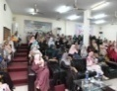
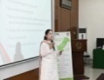
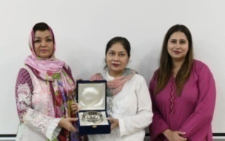
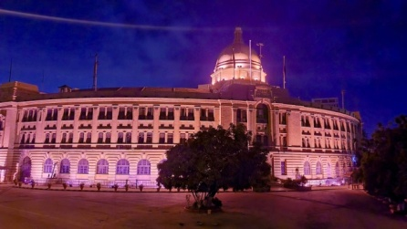
In continuation of its commitment towards well-being of humanity, KPT has undertaken a significant initiative to become part of international Breast Cancer awareness programme which aims to educate and empower women about the early detection and treatment of this disease which impacts significantly. In this regard a session was organized at KPT Staff College for the officers and staff employees which was conducted by a renowned guest speaker Dr Fareya Usmani. Information about prevention and management of Breast Cancer for the well-being of the community was shared during the occasion.
Karachi Port Trust has also earlier illuminated its landmark heritage Head Office Building with Pink lights on nights of 21st and 22nd October 2023, as a visual reminder for women to become aware of Breast Cancer.

Free Medical Camps
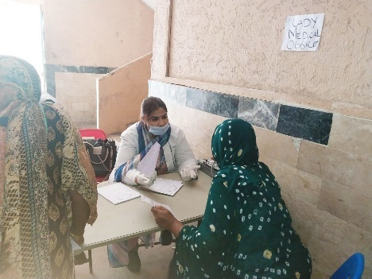

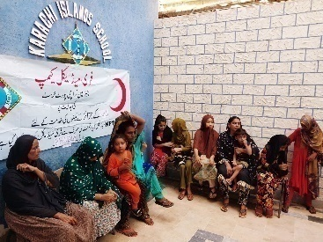
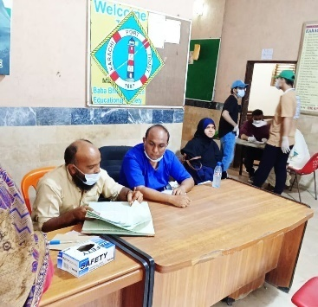
KPT Medical Team organizes free medical camps in surrounding area of KPT on regular basis. During Year 2023-24, KPT Hospital held Free Medical Camp at Manora, Baba & Bhit, Shamspir Island, etc. The medical team examined and provided medicines to more than 1300 patients. Patients mostly had skin related issues, lungs related diseases, gastrointestinal issues and chronic diseases like HTN and diabetes. Various lab tests of varied nature were also carried out.

DEVELOPMENTS
- KPT’s ongoing projects are as under:
  - Construction of Connectivity Bridge between East & West Wharves - Rs. 2,319 million
  - Reconstruction of Jetty at Boat Basin, Phase-II - Rs. 937 million

- KPT has following future projects:
  - Road Connectivity Projects:
KPT has developed an integrated road connectivity program for easing traffic congestion in and around the port area. Following projects are included in the plan:
S.No. | Projects | Cost(Millions)
A | Connectivity to Maripur Road | 3,008
B | Construction of an up-ramp to enter KGTL (PICT) | 440
C | Up-gradation of Shara-e-Ghalib between South Wharf and Bilawal Chowk | 1320
D | Construction of Flyover from SAPTL to KHAMIS Gate | 3800
E | Construction of Eastbay Expressway | 25,000
Total |  | 33,568 Million

  - Lyari Elevated Freight Corridor Project:
KPT submitted the concept proposal for the Economic Development Corporation Fund (EDCF) Loan through Ministry Of Maritime Affairs. The project was accepted by the Exim Bank Korea and they have appointed the consultant for preparing feasibility.
  - Port Infrastructure projects (Reconstruction of Oil Pier-I)
KPT has plans to reconstruct Oil Pier-I which has outlived its useful life. The project has been designed by M/s Inros Lackner (Germany). The estimated cost of the project is Rs.13,000 Million.
  - Maintenance Dredging Works
KPT intends to dredge the existing channels via Maintenance Dredging of 04 MCM and project is around USD 30 Millions.
  - LNG and LPG Jetty at South Wharf:
KPT intends to multiply its investments at South Wharf KPT’s vision is to establish a State-of-the-Art Energy Hub to cater for energy shortages by LNG/LPG Jetty along with storage facility.

  - Business District / Financial Hub @ TPX
KPT intends to develop business district at 140 Acres land at TPX. Target businesses are Banks, Insurance companies, shipping companies and media houses.

EVENTS
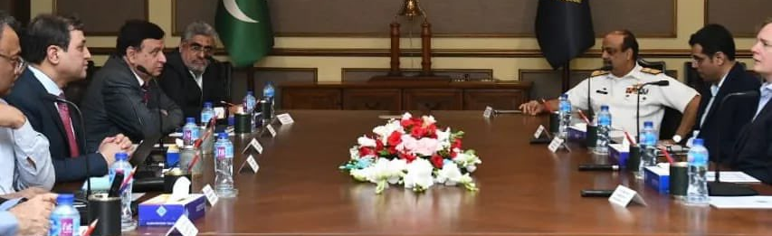
A High Delegation of Maersk Line visited KPT
Chairman Karachi Port Trust Syedain Raza Zaidi and Chairman Port Qasim Authority Rear Admiral (R) Syed Hasan Nasir Shah HI(M), along with General Managers of KPT, convened a high-level meeting at KPT Head Office with Maersk Line delegation on 24th April 2024. The delegation was led by Mr. Keith Svendsen, Chief Executive Officer of APM Terminals.
The meeting remained focused on exploring avenues for investment available at both the ports of Karachi. Discussions centered on strategic collaboration and potential opportunities for enhancing port infrastructure and operations. The delegation from Maersk Line expressed keen interest in furthering partnerships with KPT and PQA, recognizing the ports' significance in facilitating trade and commerce

KPT Celebrated World Ocean Day with a focus on marine conservation
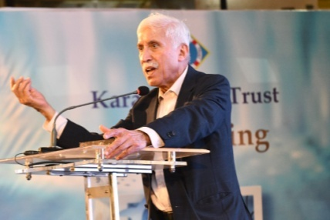
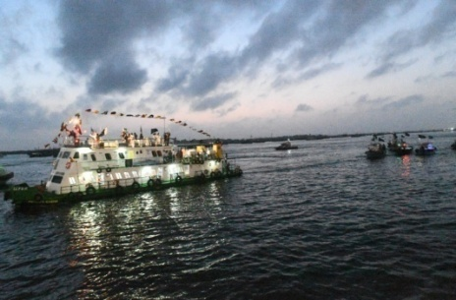
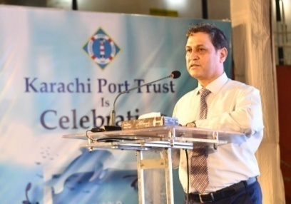
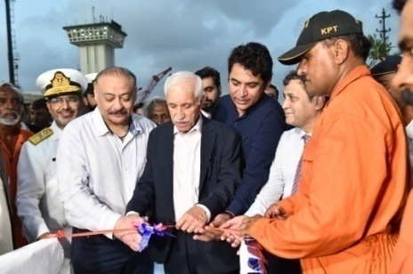
KPT has highlighted the importance of marine conservation and sustainable practices while organizing a special ceremony to mark World Ocean Day on 8th June 2024. The event was well attended by esteemed guests. Federal Minister for Maritime Affairs, Mr. Qaiser Ahmed Sheikh was the chief guest on the occasion. He was accompanied by Chairman KPT, Syedain Raza Zaidi, General Managers and other stakeholders. The proceedings aimed at underscoring the crucial role of oceans in supporting life on Earth.
Minister for Maritime Affairs Mr. Qaiser Ahmed Sheikh reiterated the significance of marine conservation efforts, stressing the urgent need to expand mangrove forests for safeguarding marine life and coastal ecosystems. The Minister emphasized the critical role of oceans in sustaining life on Earth and urged for a global commitment to ocean protection for the benefit of all.
Earlier in his welcome address, the Chairman KPT Syedain Raza Zaidi underlined the potential of the Blue Economy and emphasized the necessity of harnessing ocean resources while maintaining the health of marine ecosystems. He called for the preservation of marine habitats and stringent measures to control various forms of sea pollution, aligning with the theme “Catalyzing Action for Our Oceans and Climate” of World Oceans Day 2024.
KPT Board of Trustees convened its Final Meeting
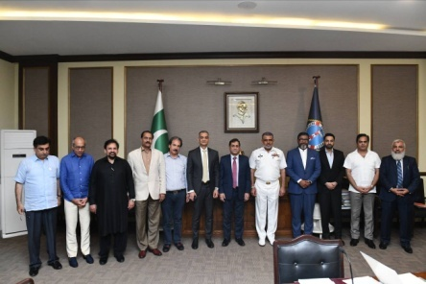
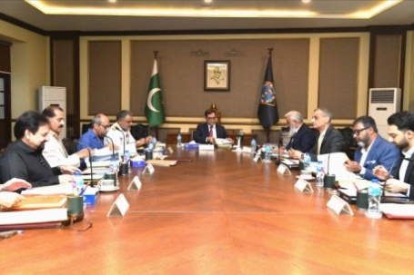
The KPT Board of Trustees, established on 5th August, 2022, convened its final meeting as its tenure concluded on 15th May 2024. Chairman KPT, Syedain Raza Zaidi, expressed gratitude and extended best wishes to all esteemed board members for their future endeavors.
The Board's contributions have been invaluable to KPT's progress and success during its tenure. Their dedication and expertise have significantly contributed to the organization's achievements.
Chairman KPT Syed Raza Zaidi acknowledged the collective efforts of the Board in steering KPT towards its goals and objectives. Their commitment to excellence has played a vital role in shaping KPT's trajectory and ensuring continued growth and success.

Karachi Port Trust Demonstrates Solidarity with Kashmiri People

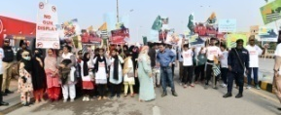

Karachi Port Trust (KPT) organized a solidarity walk in support of Kashmiri people on February 5, 2024, at Nishan-e-Pakistan, Sea-View. Chairman KPT, Syedain Raza Zaidi, led the walk, joined by dignitaries including Mr. Altaf Sario, Deputy Commissioner (South), Mr. Mansoor Rajput, Director of Information, and Mr. Nasir Ali, an Ex-Olympian. The procession marched from Nishan-e-Pakistan to Chunki-Monkey, with KPT officials and students of KPT Schools participated fervently. Chairman KPT emphasized Kashmiri people’s struggles and the inevitable quest for independence from India. The walk symbolized KPT’s unwavering support for rights and freedom of Kashmiris. The walk also served as a powerful protest against the Indian Government’s implementation of Act 35-A, which encroaches upon the sovereignty of Jammu & Kashmir.

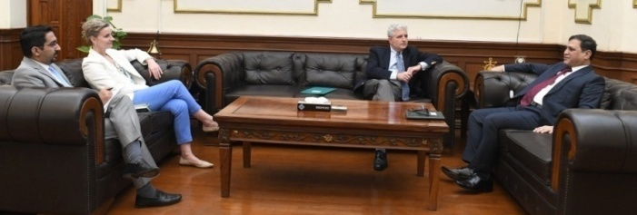
The U.S. Consul General paid a visit to the Karachi Port Trust (KPT) Head Office
Mr. Conrad Tribble, the United States Consul General in Karachi, extended a courtesy visit to Chairman KPT, Syed Syedain Raza Zaidi on 30th November 2023. Accompanying him were Ms. Shelley Saxen, Political-Economic Section Chief, and Mr. Fahd Zaidi, Economic Adviser. The meeting remained focused on elevating port efficiency, enhancing road and railway connectivity fostering environmentally sustainable shipping practices during the occasion.
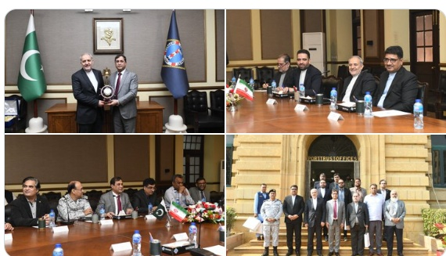
Chairman KPT welcomes Iranian Ambassador at Karachi Port Trust Head Office
The Ambassador of Iran, Raza Amiri Moghaddam, visited KPT Head Office on 21st November 2023. The Discussion on potential areas of collaboration in maritime sector of the two brotherly countries, Iran and Pakistan, focusing on commencement of trade and ferry service activities have taken place during the occasion. The delegation also toured the Ferry Terminal at West Wharf and witnessed container handling operations at the South Asia Pakistan Terminals Limited (SAPTL) with motive to strengthen maritime ties and bilateral relations with Pakistan

Former SAPM on Maritime Affairs called on Chairman KPT
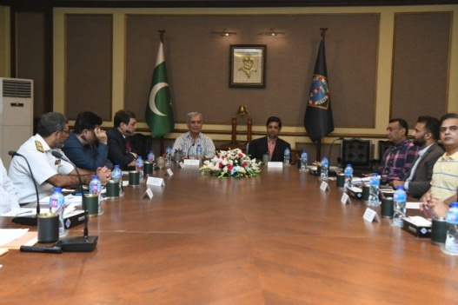
Former Special Assistant to the Prime Minister on Maritime Affairs, Vice Admiral (R) Iftikhar Rao, and the Provincial Minister for Tourism, Environment, and Climate Change, Arshad Wali Muhammad, visited Karachi Port Trust on 21st October, 2023.
Chairman KPT Syed Syedain Raza Zaidi, accompanied with General Managers, provided them a comprehensive briefing on KPT’s performance, highlighting its role in bolstering the country’s economy, ongoing development projects, and future plans aimed at positioning Pakistan at the forefront of global progress.
During the meeting, discussions were centered on matters of mutual interest, with a specific focus on promotion of tourism, water sports, and the conservation of the marine environment. The officials engaged in a constructive dialogue, exploring potential avenues for collaboration and the exchange of ideas to advance these shared objectives.
Ate
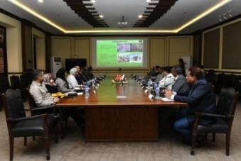
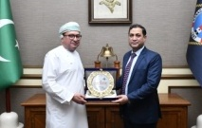
A delegation from the Sultanate of Oman visted KPT
A distinguished delegation from the Sultanate of Oman, comprising senior officers and logistics representatives, visited Karachi Port Trust on 12th December 2023. The purpose of the visit was to explore potential joint ventures and business opportunities, between Oman and Pakistan, especially in the logistics and maritime sectors. Areas of cooperation and to leverage the strategic advantages of both countries to enhance trade and economic growth were identified during the meeting. Later, the delegation accompanied with Chairman KPT proceeded to visit Port area.
KPT organized a Mangrove Plantation Drive for Climate Action
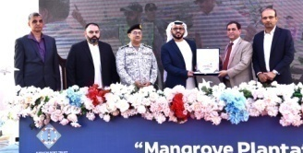
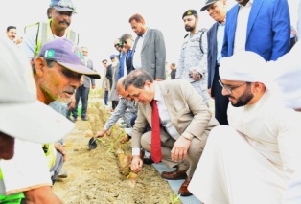
KPT organized a Mangrove Plantation drive in collaboration with Karachi Gateway Terminal Limited (KGTL) on 19th December 2023. In this regard, a ceremony held at the seafront facing mangroves. The Chief Guest of the ceremony was His Excellency Mr. Bakheet Ateeq Al Rehmiti, Consul General of UAE in Karachi accompanied with Mr. Syedain Raza Zaidi, Chairman KPT, Mr. Khurram Aziz Khan, Chief Executive of KGTL and General Managers of KPT.
Mr. Syedain Raza Zaidi, Chairman KPT, while addressing the gathering, highlighted the importance of preserving Pakistan's natural beauty amid environmental challenges. He emphasized the need to combat climate change, highlighting its adverse effects on the country, such as unexpected weather patterns, forest reduction, and coastal degradation.
During his speech, he invited KGTL to join hands in restoring mangrove forest along the Karachi coastline. This joint venture aims to conduct annual mangrove plantations with plans to designate the area as the “Mangroves Park of KPT”.
The Chief Guest, His Excellency Mr. Bakheet Ateeq Al Rehmiti further elaborated the significance of mangroves to protect aqua marine life and adverse affects of climate change and stressed upon the need for collective action. The event showcased a commitment to creating a cleaner Karachi harbor surrounded by lush mangroves, aligning with the city's growth and development.
Afterwards, KPT’s senior officers, media representatives, students and other attendees have planted 500 mangroves sapling along with Chairman KPT, CEO KGTL, all General Managers and Chief Guest, the Consul General of UAE in Karachi.
Participants of Maritime Security Workshop (MARSEW-6) visited KPT
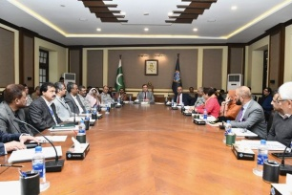
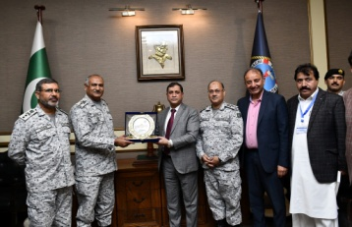
A delegation comprising 83 participants representing the Maritime Security Workshop 2023, in conjunction with a team of 5 members from the Pakistan Naval War College (PNWC), visited Karachi Port Trust on 11th December 2023. This visit played an important role in bridging gap between theoretical knowledge and practical applications mandatory for achieving goals of maritime industry and shipping sector.
Mr. Syedain Raza Zaidi, Chairman KPT presided the session, during question and answers session following the briefing given to participants during the occasion to engage them in two way discussion on areas of mutual interest.
Anti-Encroachment Drive: Safeguarding City Aesthetics and Accessibility
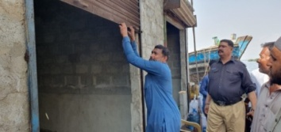

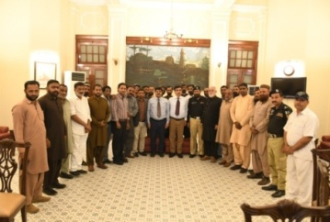
The Anti-Encroachment Department has successfully reclaimed valuable KPT land in various areas such as Sikandarabad, Hijrat Colony, Machar Colony, and Docks Colony through 85 individual and 3 joint operations. These achievements were made possible through collaborative efforts with the Sindh Police and Port Security Force. The Anti Encroachment Department vacated 89805 square yards of land through individual operations by demolishing various structures. Additionally, specific illegal encroachments were addressed, including the peaceful reclamation of KPT Quarters at Building # M-16, Manora, decisive measures against encroachers at Boat Building Yard, West Wharf, and the demolition of an illegal structure at Machar Colony, reclaiming 200 square yards of land. All vacated properties, including land, quarters, and shops, were transferred to the Estate Department. The General Manager (RED) commended the AE Team.

TRAINING & DEVELOPMENTS

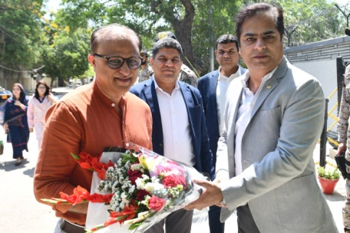
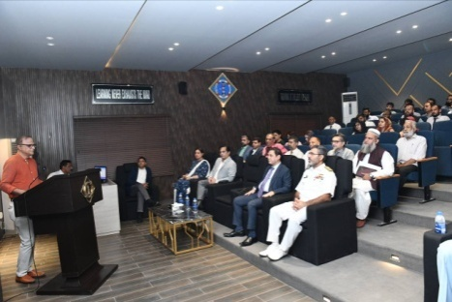
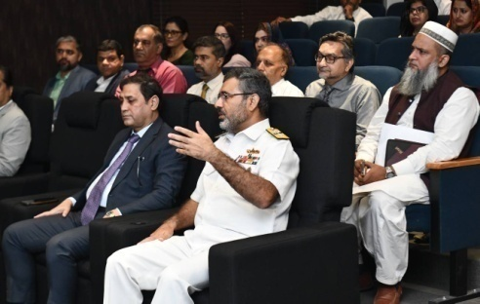
Informative Session on "Smart Cities and Climate Change" Held at KPT Staff College

KPT Staff College hosted an enlightening session featuring Mr. Farhan Anwar, Urban Planning Consultant on 16th May 2024. Mr. Farhan delivered a compelling talk on "Smart Cities and Climate Change," shedding light on the impacts of climate change and potential solutions. The session aimed to raise awareness and foster understanding among attendees about this critical issue.

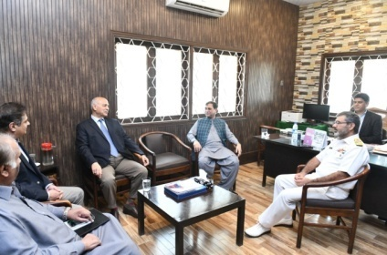
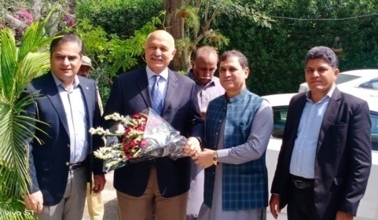
Mr. Mushahid Hussain Syed Delivered lecture on Strategic Significance of Pakistan

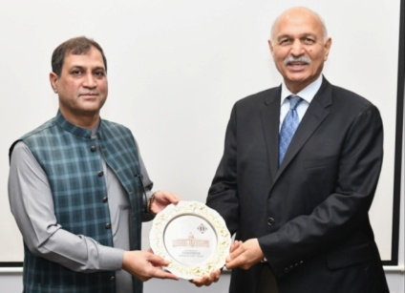
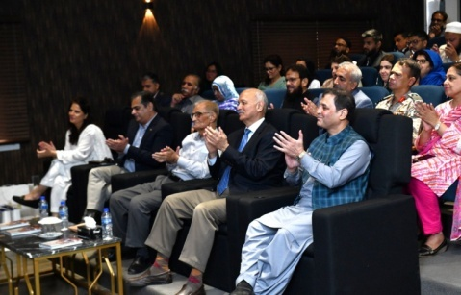
KPT Staff College hosted as session of an eminent speaker, Senator Mushahid Hussain, who delivered a comprehensive talk on the "Strategic Significance of Pakistan - Challenges & Way Forward" on 4th June 2024,. The event was attended by Chairman KPT, Syedain Raza Zaidi, alongside KPT General Managers and officers, as part of the organization's ongoing intellectual grooming initiative.
Senator Hussain's insightful address explored a deep strategic landscape surrounding Pakistan as well as the multifaceted challenges and charting a path towards a more secure and prosperous future. The session was marked by an engaging interactive Q&A segment, where the audience had the opportunity to engage with the speaker and gain a deeper understanding of the complex issues at hand.

KPT Hosted Educational Visit for Ilmsters School Students
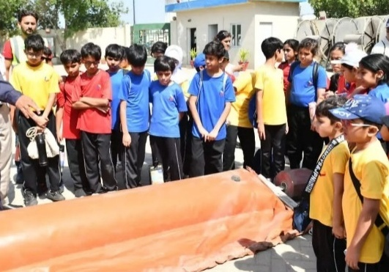
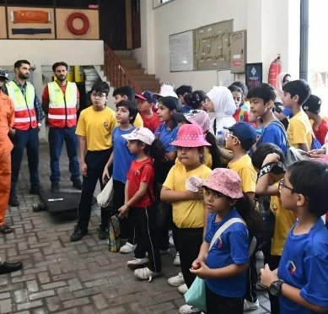
KPT welcomed 23 young explorers, grade 5 students along with their teachers from Ilmsters School on 25th April, 2024. The students visited the Marine Pollution Control Department to gain insights of human impact on the marine environment and to explore innovative solutions to combat pollution. Through interactive sessions and hands-on experience, the students learned about the various challenges facing marine ecosystems and the role they play in preserving these vital habitats.
KPT remains committed to fostering environmental awareness and empowering youth to become stewards of our planet's oceans. By engaging with young minds and providing educational opportunities, KPT continues to promote sustainable practices to advocate protection of our marine environment.

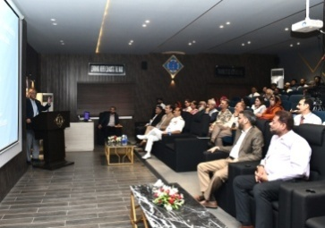
Lecture on "The Ideology of Pakistan - Journey of a Nation
The distinguished Senator (R) Javed Jabbar graced the KPT Staff College with an enlightening lecture titled "The Ideology of Pakistan - Journey of a Nation" on 26th June 2024 at KPT Staff College. The event, aimed at enriching the intellectual growth and knowledge of KPT officers, proved to be a resounding success.
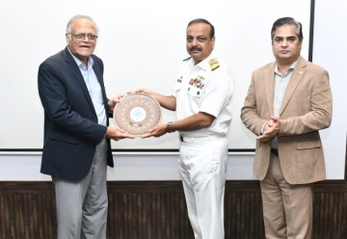
Senator (R) Javed Jabbar captivated the audience with his insightful analysis of Pakistan's ideology and the evolution of the nation over the years. His thought-provoking exploration of the nation's journey resonated deeply with the attendees, sparking thoughtful discussions and reflections among the KPT officers.
The lecture was followed by an engaging Q/A session, where the audience had the opportunity to delve deeper into the topics discussed and gain valuable insights from Senator (R) Javed Jabbar's expertise.

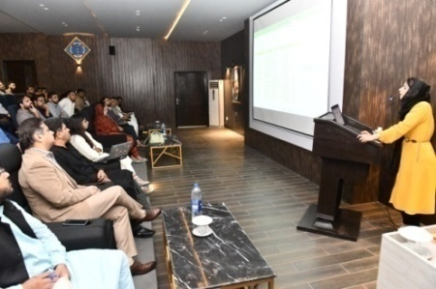
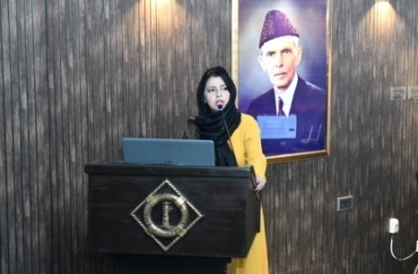
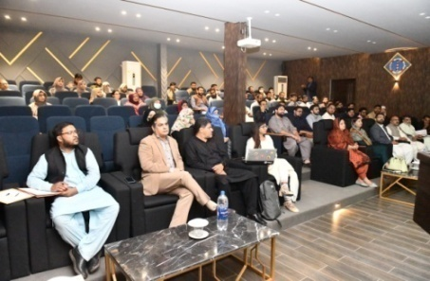
Computer Modern Techniques / Skills Course
A comprehensive two-day course on computer modern techniques and skills conducted by Ms. Sumera Ghouri, a certified Microsoft Office Specialist (MOS) at KPT Staff College from 13th to 14th June 2024.
During the course, Ms. Sumera explained the latest advancements in computer technology, shedding light on innovative ways to implement these advancements. Participants had the opportunity to enhance their knowledge and skills in the ever-evolving world of technology.

Renowned Economist Tariq Bajwa Illuminated on Public Finance Management!
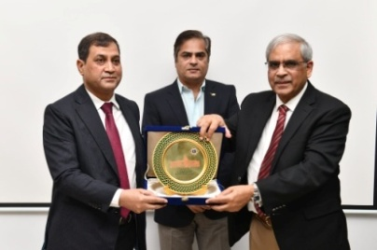
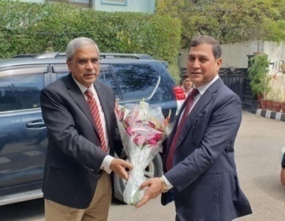
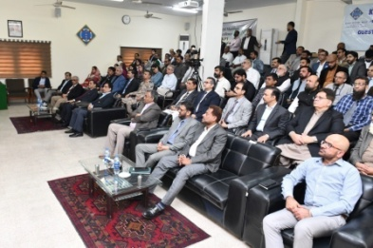
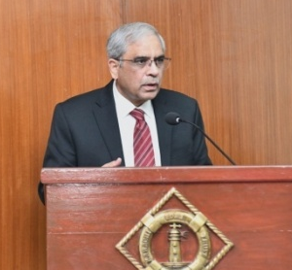
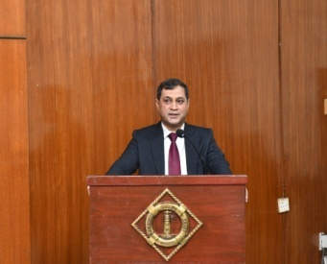
Former Governor of the State Bank of Pakistan, Mr. Tariq Bajwa, delivered an insightful talk on "Public Finance Management" to officers at the KPT Staff College on 5th March 2024. The session encompassed discussions on Financial Policies, Budgeting, Accounts, Audit, and more, culminating in an engaging Question & Answer segment. Chairman KPT Syedain Raza Zaidi thanked Mr. Bajwa and presented a souvenir to conclude the event.

Session on "The Genesis and Heritage of Pakistanis”

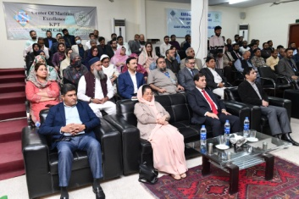
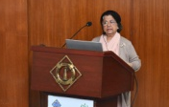
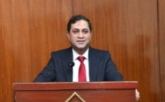
Barrister Shahida Jamil led an engaging session on "The Genesis and Heritage of Pakistanis", organized at KPT Staff College on 4th February 2024. The talk delved into the historical and archaeological aspects of the region, emphasizing the importance of continuous learning for national prosperity.
Attendees were captivated by Barrister Shahida Jamil's insights, which highlighted the rich civilization that has influenced Pakistan’s identity. The session served as a reminder of the value of understanding our past for a brighter future, which shows KPT's dedication to intellectual discourse and cultural awareness.
Embracing AI for Sustainable Port Operations
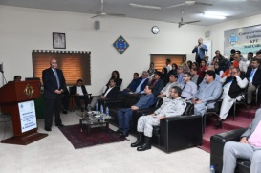
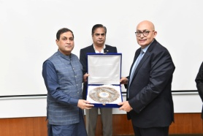
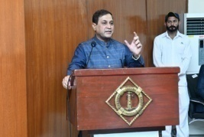
An enlightening session took place at the Staff College on 16th February, 2024, focusing on the adoption of sustainable technologies and the implementation of Net Zero initiatives in ports. Dr. Shahid Mahmud delivered a thought-provoking talk, shedding light on the crucial intersection of environment, technology, and artificial intelligence (AI).
The attendees were provided with valuable insights into the transformative potential of AI in port operations, highlighting the significance of staying at the forefront of technological advancements to ensure environmental sustainability.

Awareness Session on Promoting a Healthy Lifestyle
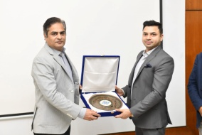
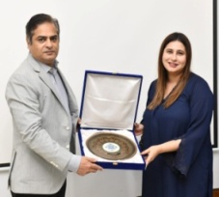
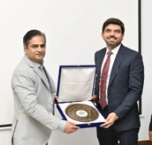
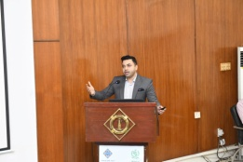
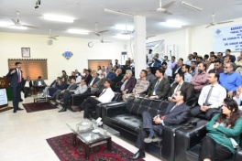
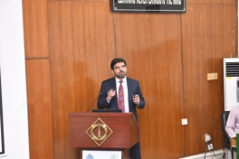
A session on "Healthy Lifestyle" was conducted by Cardiologists Dr. Usman H. Bhatti and Dr. Umair Abrar from OMI Hospital at KPT Staff College on 20th February, 2024. The esteemed speakers underscored the importance of preventive measures, focusing on aspects such as healthy food intake, engaging in physical activities, effective stress management, and maintaining discipline in daily life.
The session served as a valuable opportunity for attendees to gain insights into the significance of adopting a healthy lifestyle to enhance overall well-being and prevent cardiovascular diseases. Dr. Usman H. Bhatti and Dr. Umair Abrar's expertise and guidance provided a holistic approach to promoting health and wellness among the KPT community.
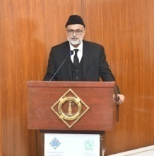
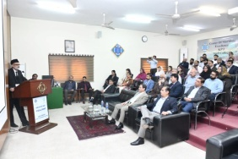
Talk on Exploring Fiscal Crime and Ethics
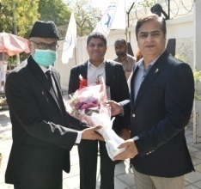
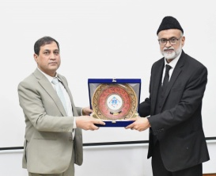
KPT hosted a thought-provoking workshop on "Fiscal Crime" led by Justice (R) Syed Mahmood Alam Rizvi at the KPT Staff College on 22nd February, 2024. The session explored into the intricate issues surrounding fiscal crime, with a focus on moral ethics, integrity, and individual accountability.
Justice (R) Syed Mahmood Alam Rizvi's perceptive discourse shed light on the ethical considerations and legal implications associated with fiscal misconduct. Attendees had the opportunity to engage in discussions that highlighted the importance of upholding moral values, practicing integrity, and taking personal responsibility in matters related to fiscal governance.
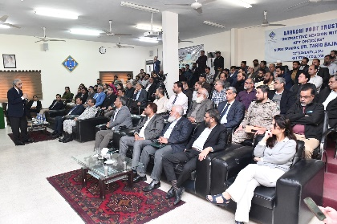
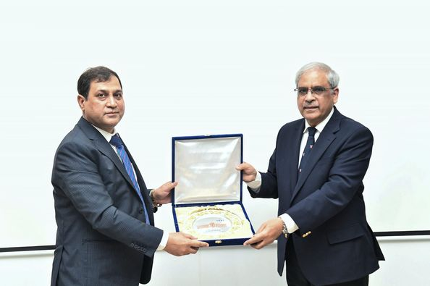
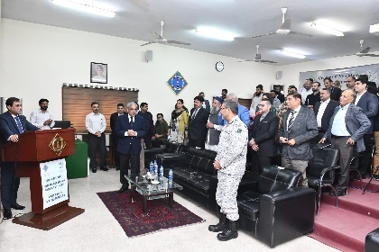
Interactive Session to Discuss Prevailing Economic Issues
An engaging session with Mr. Tariq Bajwa, former Governor of the State Bank of Pakistan, took place at the KPT Staff College on 22nd January, 2024. The esteemed guest speaker addressed matters pertaining to public services and shared his experience during an insightful discussion on the prevailing economic issues in the country. A significant turnout of esteemed participants, including Chairman KPT Syedain Raza Zaidi, General Managers, Heads of Departments, and other officers, all of whom displayed a keen interest in the discourse on these critical issues.
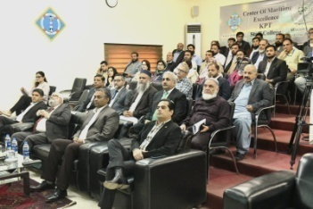
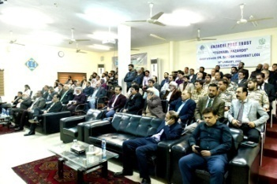
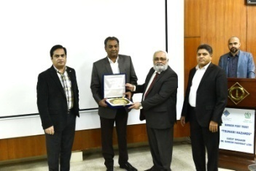
A Session held on "Tsunami Hazards"
A session focusing on "Tsunami Hazards" was conducted at KPT Staff College on 4th January, 2024. The session featured a comprehensive presentation by Dr. Sarosh Hashmat Lodhi, Vice Chancellor of NED University. He shared valuable insights on the topic. The KPT officials were engrossed by Dr. Lodhi's expertise and gained significant knowledge from the session. The event concluded with a presentation of a memento, recognizing Dr. Lodhi's profound understanding of the subject matter.

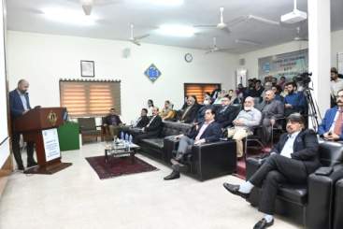
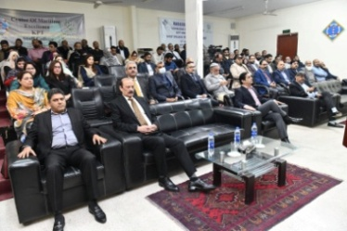
An Interactive Session: Leveraging Culture
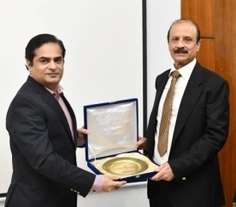
An interactive session titled "Harnessing Cultural Assets to Enhance Pakistan's Positive Image" was conducted at KPT Staff College on 10th January, 2024. The session, led by Mr. Kamran Lashari, Director General of Walled City Authority Lahore, provided valuable insights into leveraging cultural resources to bolster Pakistan's favorable global perception. The audience was thoroughly captivated by the session's exploration of this important subject matter.

Economic Potential of Pakistan's Ports, Shipping, and Maritime Tourism seminar concluded at KPT Staff College
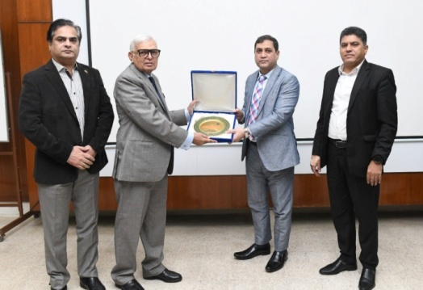
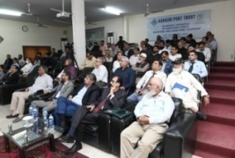
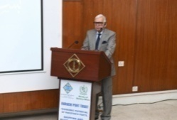
A seminar focusing on the "Economic Potential of Pakistan's Ports, Shipping, and Maritime Tourism" took place at KPT Staff College on 2nd November 2023. The lecture was delivered by the guest speaker, Cdre. Dr. Anjum Sarfraz, an Honorary Fellow of the National Institute of Maritime Affairs, attracted a significant number of participants that includes General Manager (Admin) Brig. Tariq Bashir TI(M), General Manager (Planning & Development) Mr. Raghib ul Khair, General Manager (Finance) Mr. Mashoud Jan and other senior management officials. The learned session concluded with award of memento to Dr Anjum Sarfaraz during the occasion.
Session on "Pakistan's Maritime Potential"
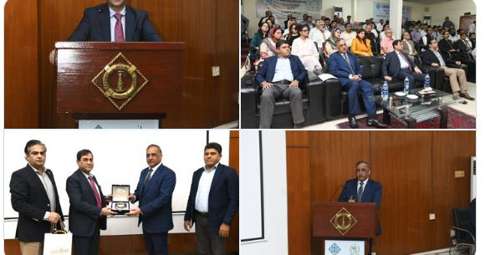
Dr. Sajid Mehmood, the Vice Chancellor of Minhaj University (Lahore), delivered an insightful lecture at KPT Staff College on the subject of "Pakistan's Maritime Potential." Throughout his presentation, the esteemed speaker emphasized on tapping untapped potential of Pakistan's maritime resources which plays crucial role and contributes well to the national economy. The session concluded with the presentation of Memento by Chairman KPT Syedain Raza Zaidi to the learned guest speaker during the occasion.
Talk on "Pakistan Economic crises and the path ahead"
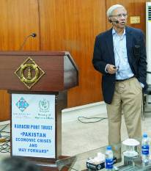
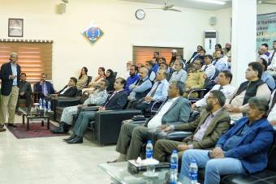
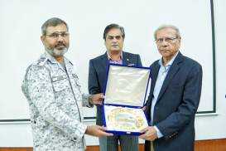
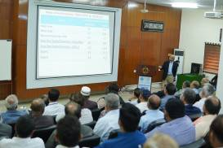
A seminar titled "Pakistan's Economic Challenges and Future Prospects" took place at the KPT Staff College on 13th November 2023. The renowned economist, Dr. Kaiser Bengali, was specially invited to share his expertise on the subject. His presentation not only provided valuable insights but also significantly raised awareness among the attendees about the economic challenges confronting Pakistan and potential pathways for future. It is noteworthy that all participants demonstrated a keen interest and remained actively engaged throughout the duration of the lecture session.
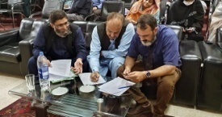
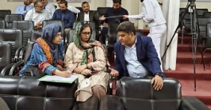
Interactive Session on Proficiency/Training need Analysis
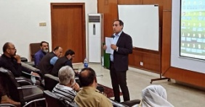
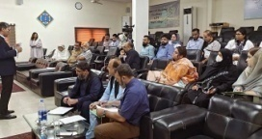
KPT organized an interactive session with IBA professionals at KPT Staff College on October 18, 2023. 47 Officers from different departments of KPT participated in two groups, with the goal of conducting a proficiency and training needs analysis.
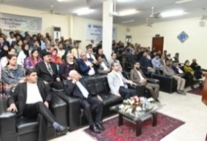
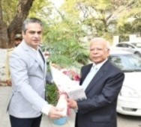
Dr. Ishrat Husain, Ex-Governor SBP, delivers a lecture on “Development Pathways and Overcoming Economic Hurdles”
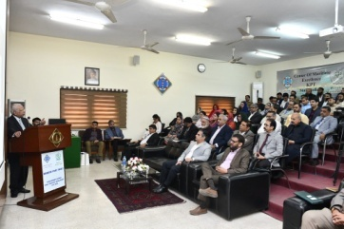
Dr. Ishrat Husain, the former Governor of the State Bank of Pakistan, delivered an detailed presentation on the Development Pathway and prevalent economic impediments on 13th December 2023 at KPT Staff College. His comprehensive analysis shed light on the challenges that have impacted our economic landscape over the past four decades. Dr. Husain's talk gave us a valuable view on the many factors that are causing our economic problems. It helped us understand the history and current challenges that are stopping sustainable growth.
The discourse culminated in an engaging an interactive Q&A session, which further enriched the exchange of ideas and perspectives on the economic trajectory and potential remedies.
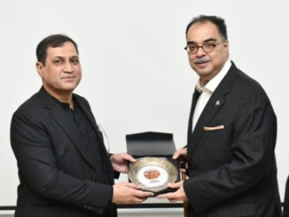
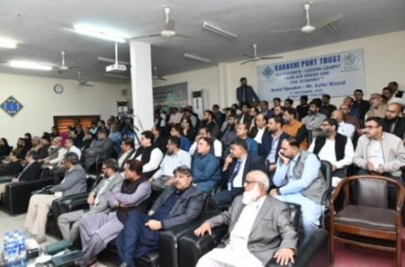
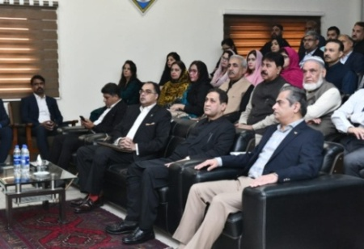
Interactive Session with the Solo Survivor of an Airplane Crash, Mr. Zafar Masud, CEO of BoP
KPT organized a captivating and thought-provoking interactive session featuring Mr. Zafar Masud, CEO of Bank of Punjab, held at KPT Staff College on 1st December 2023. The speaker shared a remarkable and inspiring account of surviving a plane crash in Karachi. Throughout the session, Mr. Masud drew upon his expertise to provide valuable insights into Pakistan's economy and offered suggestions aimed at enhancing port efficiency.
Chairman KPT, Mr. Syedain Raza Zaidi, along with General Managers and Heads of Departments of Karachi Port Trust has attended the session with keen interest. Attendees had a valuable opportunity to engage in meaningful discussions and gain insights into these crucial subjects.
On conclusion, Chairman KPT presented a souvenir to the Mr. Zafar Masud.
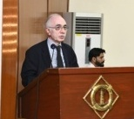
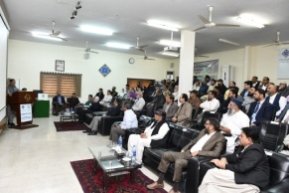
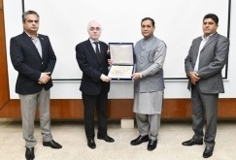
KPT organized a session tiled China Pakistan Economic Corridor (CPEC)
A session to understand the Causes of Slow Progress and Charting a Way Forward on CPEC took place at KPT Staff College on 8th December 2023. A former Ambassador Mr. Masood Khalid enlightened in a presentation and shared valuable insights with KPT officers on the origins, vision, mission, economic potential, and effectiveness of CPEC. Mr. Syedain Raza Zaidi, Chairman KPT, praised Mr. Khalid's informative lecture and presented him a memento to mark the conclusion of the day's event.

SPORTS
Mr. Anas Khan bags the 5th KPT Squash Championship 2024 Trophy
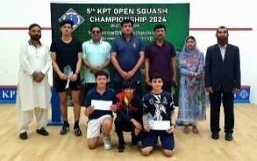
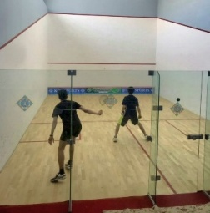
Mr. Anas Khan emerged victorious in the 5th KPT Squash Championship 2024, defeating Abdul Basit from the Pakistan Navy in a thrilling final match on 27thApril 2024, at the KPT Sports Complex. KPT Sports Complex hosted the championship showcased intense competition among players from across Karachi, demonstrating the spirit of sportsmanship and athleticism inherent in Squash.
Administration Division Emerges Victorious in KPT Interdivisional Football Competition 2024
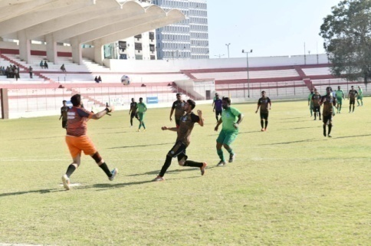
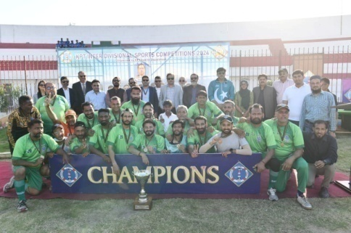
Karachi Port Trust organized the “KPT Interdivisional Football Competition 2024” at the KPT Sports Complex. The tournament commenced on March 4, 2024, and concluded on March 6, 2024. Eight teams showcased their talents in a ceremony inaugurated by Chairman KPT and General Managers, setting the stage for an exhilarating competition.
Following intense matches, the final showdown on March 6, 2024, featured the Administration and Engineering Divisions. Harjivan and Faraz Patel from the Administration Division exhibited remarkable teamwork, scoring the winning goals and securing victory for their team. Brig Tariq Bashir TI(M), General Manager Administration, graced the finale as the Chief Guest and distributed awards amongst them.
KPT Organized Annual Indoor Rowing Regatta – KPT team clinches Bronze Medal

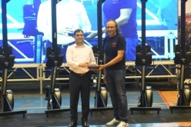

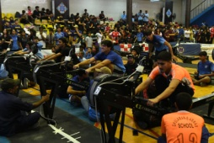
Annual Indoor Rowing Regatta, jointly organized by the Karachi Port Trust (KPT) and Karachi Boat Club (KBC), was contested by 700 students from 28 schools and universities at the KPT Sports Complex on 29th October 2023.
KPT team has also taken part in the event and won Bronze Medal in the Under-15 Category during the occasion.
Chairman KPT, Syed Syedain Raza Zaidi, graced the occasion as chief guest and awarded medals to the winners during the occasion.
The Rowing Regatta, hosted by KPT, has become a prominent event in recent years, underlining KPT’s dedication for promoting sports and nurturing a culture of wholesome competition.

KPT distributed Android Tablets amongst Rowing Regatta Winners
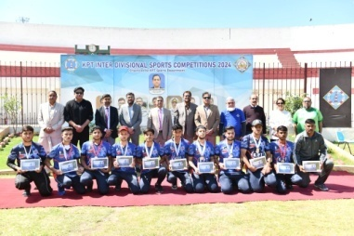
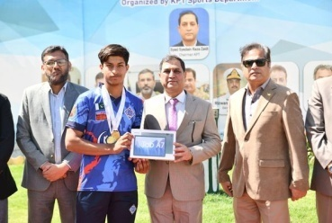
In a ceremony at the KPT Sports Complex on 4th March, 2024, KPT awarded Android Tablets to the winners of the KPT School Students Rowing Regatta during the Interdivisional Football Competition inauguration. Chairman KPT, Syed Syedain Raza Zaidi, honored the Gold, Silver, and Bronze medalists and praised the athletes and their coach for their exceptional achievements. Chairman KPT accompanied with General Manager Administration, Brigadier Tariq Bashir, General Manager Finance, Mr. Mashoud Ahmed Jan, and General Manager Civil Works/Engineering, presented the Android Tablets to the students on behalf of KPT. The event was a memorable and rewarding experience for all those in attendance.
3rd KPT Ramadan Snooker Tournament 2024
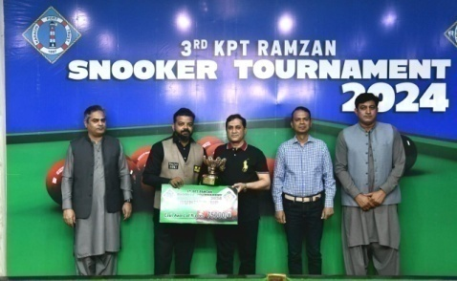
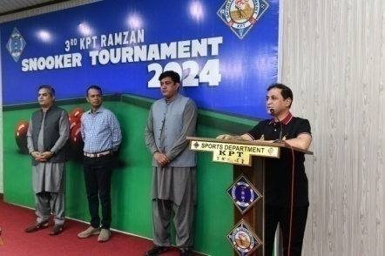
The 3rd KPT Ramadan Snooker Tournament kicked off on 1st Ramazan-ul-Mubarak at the KPT Sports Complex. Rear Admiral Rizwan Ahmed, SI(M), General Manager Operations inaugurated the tournament. The tournament witnessed the participation of renowned national-level players.
In a thrilling finale, which took place on 29th March 2024, Mr Zulfiqar A Qadir and Mr. Mr Ian Mark John battled their way to the top, showcasing exceptional skills and sportsmanship. Ultimately, Mr Zulfiqar A Qadir emerged victorious, claiming the championship title. Chairman KPT Syedain Raza Zaidi honored the winner and the runner-up with cash awards and trophies, recognizing their outstanding performances throughout the tournament.

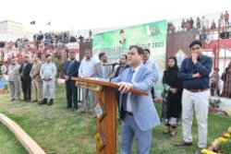
KPT Football Challenge Cup 2023

The 3rd KPT Football Challenge Cup 2023 came to an exhilarating end at the KPT Sports Complex on 15th January, 2024. The tournament commenced in December 2023, with esteemed sports celebrities joined the Chairman KPT Syedain Raza Zaidi in inaugurating the event. The final match and subsequent closing ceremony attracted a large and enthusiastic crowd of spectators. The final match was featuring moments of brilliance that kept the audience thoroughly engaged. Ultimately, Mohammadan Baloch emerged as the victors, securing the trophy with a hard-fought 1-0 win over Burma Afridi.

